**Assignment #3 –**Recommender Systems

Jose Muniz

301316969

**Exercise #1**

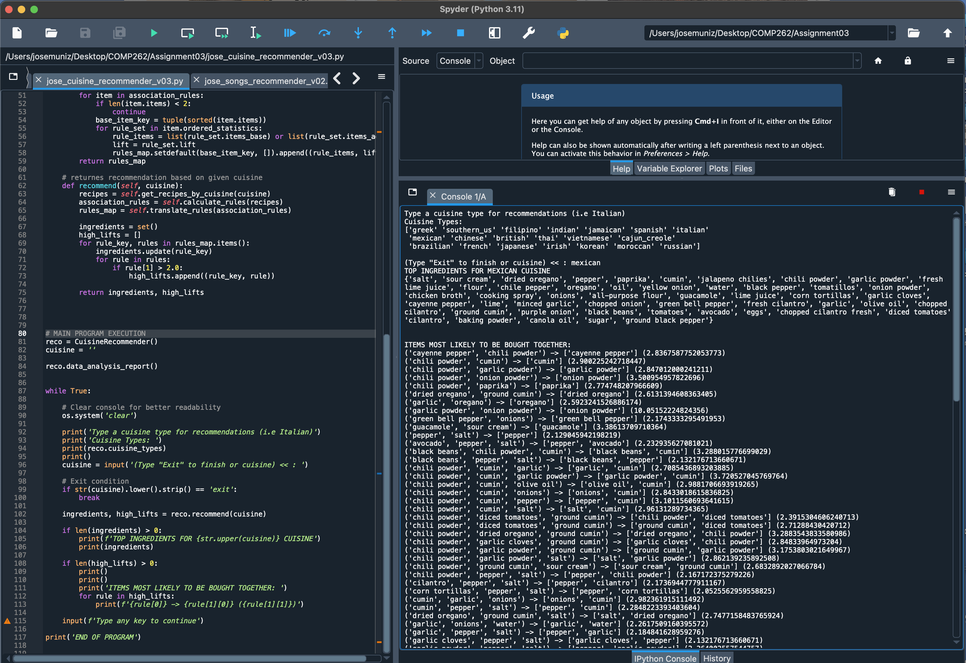

**Exercise #2**

Exploration Data:

Colums:

For the recommendation system I am using the following columns:

**Title** : The title of a song is its most distinct and direct identifier, containing crucial keywords that describe the song or its content. It's the primary way users think of and search for music.

**Description**: can provide deeper context about the song

**Also_View**: This column likely contains IDs of other songs or albums viewed by users in conjunction with the current song

I discard the following columns:

**Category**: This column does not have a direct relationship with the title of the song and is not included in the song file.

**Tech1, Tech2**: Those columns do not contain information. However, technical information about the song does not relate to the title.

**Fit**: This column has no information.

**Also_buy**: It is not relevant to the recommendation based on the title of the song.

**Brand**: It is not relevant to the recommendation based on the title of the song.

**Features**: This column has no information.

**Rank**: Don’t has direct relationship with the title of the song.

**Main Cat**: present URL address information, not textual content.

**Similar_item**: This column has no information.

**Date**: Is not relevant for recommendation, and also it has no information

**Price**: It is not relevant to the recommendation based on the title of the song.

**Asin**: It is a code and it has no relevant to the recommendation based on the title of the song

**imageURL**: It is not relevant to the recommendation based on the title of the song.

**imageURLHighRes**: It is not relevant to the recommendation based on the title of the song.

**Details**: offer specific information not directly related to the music's thematic or content-based aspects, making it less relevant for similarity-based recommendations.

**Title Length**: It is not relevant to the recommendation based on the title of the song.

OUTPUTS:

Input : “Take Me Home”

Results:

